Title: Using UML for Modeling Complex Real-Time Systems
Author: Bran Selic, Jim Rumbaugh
Article Summary:
This research paper focuses on Real Time Object Oriented Modeling (ROOM) of real time systems through the use of UML language and its notations. It is most important for a software to have strong foundation in order to have proper design functionalities, especially for real time systems as they are used mainly in crucial sectors such as aviation, security, communication etc. Also the upcoming changes should be easily accommodated in the systems which are newly developed due to the fact that requirements keeps on changing. This paper revolves around the concepts of capsules, ports, connectors, protocols and State machines which play vital roles in designing of real time system. Each of these concepts are explained at a high level of technical details for modeling and can be represented with different stereotypes and notations. Real Time complex systems are modeled through two ways: a. Structural Modeling b. Behavior Modeling. One of the fundamental element while modeling real time system is timing which needs to be kept in mind while designing the system as most of the functioning of different parts are time based and dependent on each other.

Article Analysis:
The research study Using UML for complex Real Time System has revealed significant concepts by author which are necessary to implement while designing a software for real time systems so that there are no flaws in development stage and changing requirements can easily be incorporated in the system.
The Authors started with the Structural Modeling which defines relationship between two entities of a system to be modeled. In UML class diagrams are used for static modeling. Three important concepts defined by author throughout the paper for modeling are as follows:
i. Capsules: These corresponds to actors in UML. Author described them as an object which is active most of the time and captures architectural components. They are the central component for modeling real time systems. The capsules communicates through ports with the external environment. Capsules can be decomposed into sub-capsules, but they are created and destroyed as and when required by the state machines. Capsules are represented by <<capsule>> stereotypes in UML. Also they are held in composition relationship with sub-capsules. State machines are the optional parts attached to capsules but they cannot be further decomposed. There should exist at least one state machine in capsule.

ii. Ports: They are considered to be as boundary objects which act as an mediator between the external environments and the internal system. They inculcate both structural and behavioral properties in them. Ports born and die along with the capsules. There exist two types of ports:
a. Relay Ports: These are connected to sub-capsules through connectors and helps in passing signals. As they appear at the boundary of the system, they have public visibility.
b. End Ports: These are the ones which are connected to State machine for communication of signals sent by capsules. Send and call methods are invoked for transmission of signal to end ports. They also have public visibility.
In UML ports are represented in a labeled compartment list as shown in below figure. External ports have public visibility while internal ports are protected. They are represented differently in class and collaboration diagram.
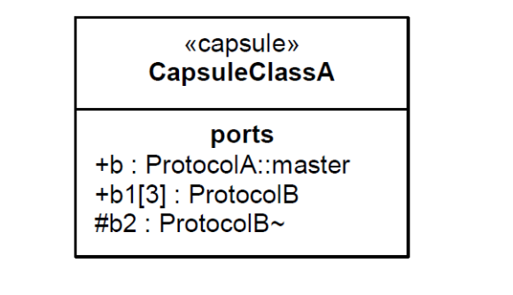
iii. Connectors: These are said to be message passing channel and represented by association relationship in collaboration diagram.
Coming on to second part of paper author then explained Behavioral modeling which uses protocol concept for specifying behavior. Below are the main concepts described:
i. Protocol: They convey behavior consisting of several set of participants, each designated with certain role to play. Protocol do not specify structural details. Each protocol have unique name, set of received and sent signals and have sequence of communications. There are two types of protocols: Binary: which involves exactly two participants, the other is Conjugate: which appears from the base of binary protocol. Protocol role are modeled by<<protocoleRole>> in UML as ClassifierRole. A protocol is represented by <<protocol>> stereotype.

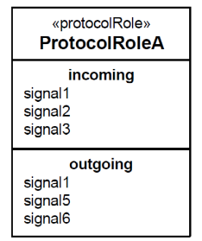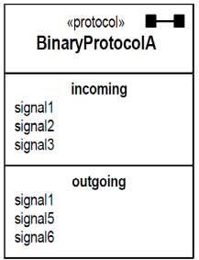
ii. State Machines: The author described abstract pattern of state machines which are of significant importance for real time systems and how can they be used with structural modeling. Fo a state machine to work properly, it have exact amount of detail incorporated in it to perform well. Author explained a chain state concept in this relevance which simply states a “pass through” state or continuation transition. They are denoted by white circles and are placed at boundary.
iii. Timing Service: A very important and critical factor which should be kept in mind while designing system is time service. Timing services are availed through the ports, they convert it into events. There can be some events executed at a point of time and some occur over an interval of time.

Article Critique:
This published paper by IBM indicates some very important aspects of modeling while designing real time systems. As these are the system are very complex, every miniature details are to be checked in the system as they need to be highly reliable and should not have technical flaws in it. Based on reading of this paper below are my observations:
Strengths:
- Author’s have true understanding of designing software architecture and how they can be modeled using UML.
- They have included sufficient amount of material and topics which is required for reader to gain an understanding of this paper.
- Author introduced concept of capsules and chain states, timing services which creates interest to UML readers.
- The paper presented has consistency of explain all details in same manner such as introduction of concept followed by UML modeling and its noatation. Distribution of paper nicely helps users in making reading easy and efficient.

Weakness:
- This paper requires will not catch attention of users who are really not into development of real-time systems.
- Reading paper throughout, and coming to end becomes monotonous.
- Author should have used some examples of real time system in order to catch the attention of users and could have retained users interest till the end.
- This paper was too lengthy in terms of describing the concepts.

